**Web Services Introduction**

▪ Servlets, JSP along with JDBC helps to develop Web Application

▪ However "Web Services" a.k.a "Application Services" helps web applications to interact with any other applications (Mobile Apps / Desktop Applications / Web Applications)

▪ Web Services, as name implies, they are the services available in "Web". They take the request from Applications, via any communication protocol such as HTTP & generate Response

▪ Web Services, is a concept, are independent of

- Platform

- Programing Languages &

- Applications

▪ Web Services take Web-applications to the Next Level!!!

▪ Unlike Web Applications, Web Services do not provide the user with a GUI. In other words Web services are meant for "Inter-System Communication / Application-to-Application Interactions but not for Users"

▪ Hence Web Services do not require the use of browsers or HTML

▪ Few real time examples of Web Services

- Mobile Apps (ex: Gmail App) communicate with their corresponding Web Applications ex: Gmail) using Web Services

- Uber / OLA Mobile Apps/Web Application interact with Google Maps using Web Services

- BookMyShow Web Application / Mobile Application interact with PVR Web Application using Web Services

▪ Web Service has two participants:

1. Service Provider / Producer

2. Service Consumer / Requester

▪ Service Provider exposes the "Service on Web" & Service Consumer uses this "Web Service"

▪ Service Provider should be a Web Application; however Service Consumer can be Desktop/Mobile Application or Web Application

▪ There are 2 types of Web Services

- RESTful Web Services

- SOAP Web Services / XML Web Services

**Why Web Services / Advantages of Web Services**

**1. Web Services Interoperability (WS-I)**

▪ Web Services are "Application, Platform and Technology Independent"

▪ Ex: VB / .NET applications can talk to Java Web Services and vice versa. Thus helping the organisations to use existing applications which are developed using other technologies (may be legacy)

▪ Also Web Services helps/allows different applications to share data among themselves

▪ Ex: Uber / OLA and Google Maps shares the data among each other

**2. Loosely Coupled**

▪ Each application is independent of one another. Hence changes done to one application will not impact the "unrelated areas"

Ex: Changes / Modifications done at Uber / OLA will not impact Google Maps

**3. No need of re-inventing the wheel**

▪ Web Services reduces the software development time

▪ This helps the other business partners to quickly develop application and start doing business

▪ This helps business to save time and money by cutting development time

Ex: Uber / OLA can make use of Google Maps

**4. Business Opportunity**

▪ Web Services will open the door for new business opportunities by making it easy to connect with partners

Ex: Dominos can get the order from Food Panda / Swiggy along with getting orders from its own site

**5. Service Reuse**

▪ Web Services takes code reuse a step further

▪ A specific service within the organisation is only coded once and used over and over again by other applications

Ex: An organization can have a "Single Payment Gateway service" which helps other web applications of that organization to interact with "Payment Gateways"

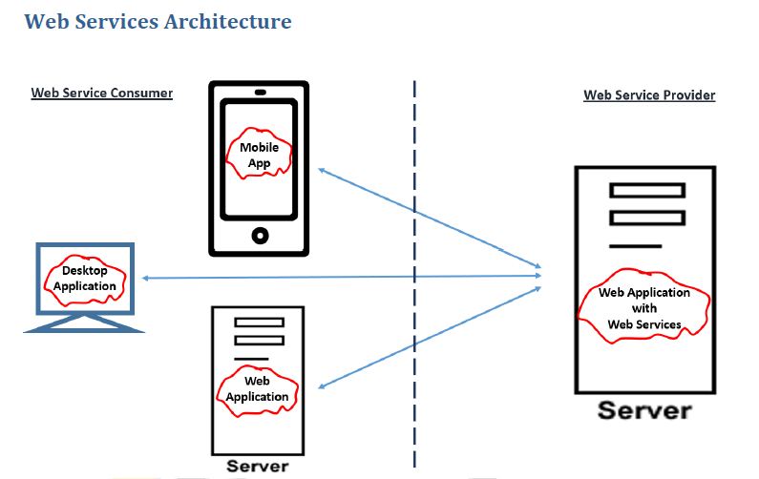

**Note:**

▪ Web Service Producer MUST be a Web Application

▪ However Web Service Consumer can be

- Web Application OR

- Desktop Application OR

- Mobile Application

▪ Web Application can “Produce” some web services as well as “Consume” some other web services. In other words, web application can have both “Producers and Consumers”